Sawmill Cottage

i. General

Sawmill cottage is a simple mid to late 19th century estate cottage, stone built, under a double pitched slated roof, with Scots slates. Today, we have access only to the exterior (N.B.: The principal elevation facing the loch, for the sake of this survey is given as the north side). This house is occupied by Liz Reynolds. It lies on the gently sloping land running up from the lochside and is slightly terraced into the hillside. The house is accessed off a small estate road running up from the lochside road, a small driveway approaching the cottage from its east side. To the south of the main cottage is an outshot and similar to the east gable wall of the cottage itself, these are sort of flanked by a sunken area and a concrete path. Up slope sit retaining walls of cemented brickwork. There is a small flight of five concrete steps running up to the access estate road to the south towards the south-east corner of the cottage.

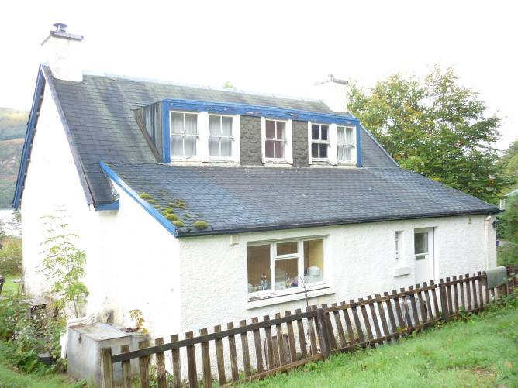
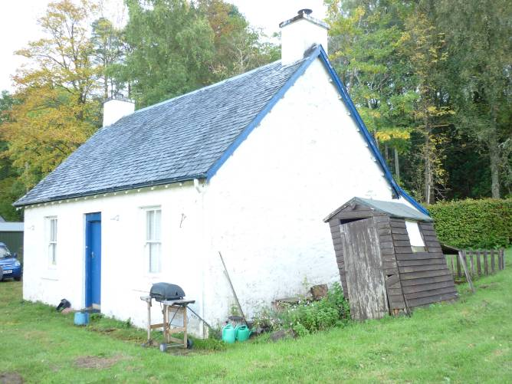
Figure 18 and 19 – Sawmill cottage from northwest (left) and southwest with outshot to rear (right).

The cottages of the typical three-bay arrangement with a central entrance in the principal elevation to the north and with small windows equally spaced on either side. The entrance no longer contains its original door but a blue painted wooden door with tongue and groove boards above two concrete steps. The windows are of sash-and-case form and appear to be original. Their detailing is of an elongated fillet-and-ovolo profile with a two- -over-two pane arrangement. The sills of the windows project and appear to be of concrete. At the north -east, north-west and south-west corners the windows are formed up with roughly hewn dressings. The eaves overhang slightly and extend beyond the line of the gable wall. The barge boarding is simply detailed, painted in dark blue. The gable walls to the east and west are surmounted by simple square chimneys that are rendered with concrete slabbed copes.

The north and west elevations are of rubble construction relatively flush pointed with some possible traces of harl on the north side. All of this painted over in white; quoining is visible below the paintwork. The east gable wall is harled in cement. Overall, the cottage is painted in white, but on the rubble elevations it is clear that the white coat overlies multiple layers of limewash of which traces remain.

The whole of the rear, the long elevation to the south, is masked by what appears to be a secondary outshot or lean-to. This sits under a monopitch catslide roof that extends out from the south pitch of the roof of the main house. The outshot is harled to the south and east but is of flush pointed rubble as exposed to the west. The west wall foot of the outshot and the south wall foot display a course of projecting small boulders, this indicating a relatively early date actually of the structure. This projecting footing only extends about half way along the south side of the extension, i.e. the western parts of the building. It is therefore possible that the eastern parts of the outshot are a secondary extension. The outshot is accessed by an entrance offset to the east. This is flanked by a very small possible pantry louvred window. The door itself is relatively modern and has a glass panel above and tongue and grooved boarding within a framed surround. To the west of this there is a broad window apparently for the kitchen.
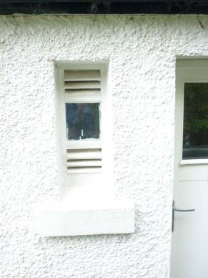
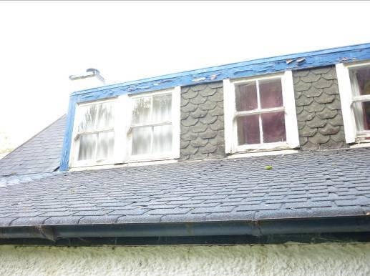
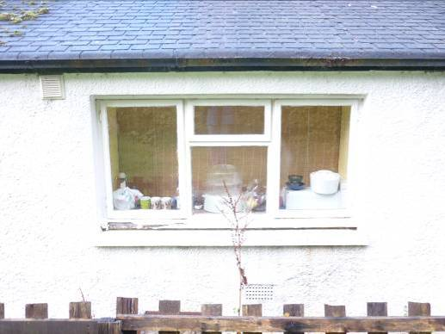

Figure 20 and 21 – External features and detailing of the rear elevation: dormer window and roofing (left), kitchen window (centre), back door and louvred window in outshot (right)

Just above the junction of the outshot roof with that of the main cottage, there is a continuous dormer arrangement containing three windows. The outer two of these are arranged in paired sash-and-cases of two-over-two. The central window is a single sash-and-case two-over-two. The outshot is wood-framed. The gaps between the windows are faced up with shaped bitumen tiles. The rear pitch of the roof and the roof of the outshot itself are similarly roofed with bitumen tiling. No slates now remain. The roof and sides of the dormer arrangement appear to be sheet metal clad, apparently in copper.

In the east wall of the outshot there is a further small window, sash-and-case, with a two-above-two configuration.

